Cairo University Faculty of Computers and Artificial Intelligence



**Software design specification document**

**2023**

**Project Team**

|  |  |  |
| --- | --- | --- |
| **ID** | **Name** | **Email** |
| 20211075 | Mohamed Ahmed Abd El-Kawy | 3ab2wy1911@gmail.com |
| 20211005 | Ahmed Shabaan | ahmedshanan2021@gmail.com |
| 20211074 | Mohamed Ahmed Ryad | moreyad06@gmail.com |
| 20210273 | Omar Mohamed Fayek | omarbenmohamed2003@gmail.com |

Contents

Class diagram design 3

Class diagram Explanation 3

Sequence diagram design 4

Github repository link 8

# 

# Class diagram design

# Class diagram Explanation

* Used Strategy Pattern
* Applied open-closed principle.
* Applied single responsibility.

# Sequence diagram design

**1 – Register**

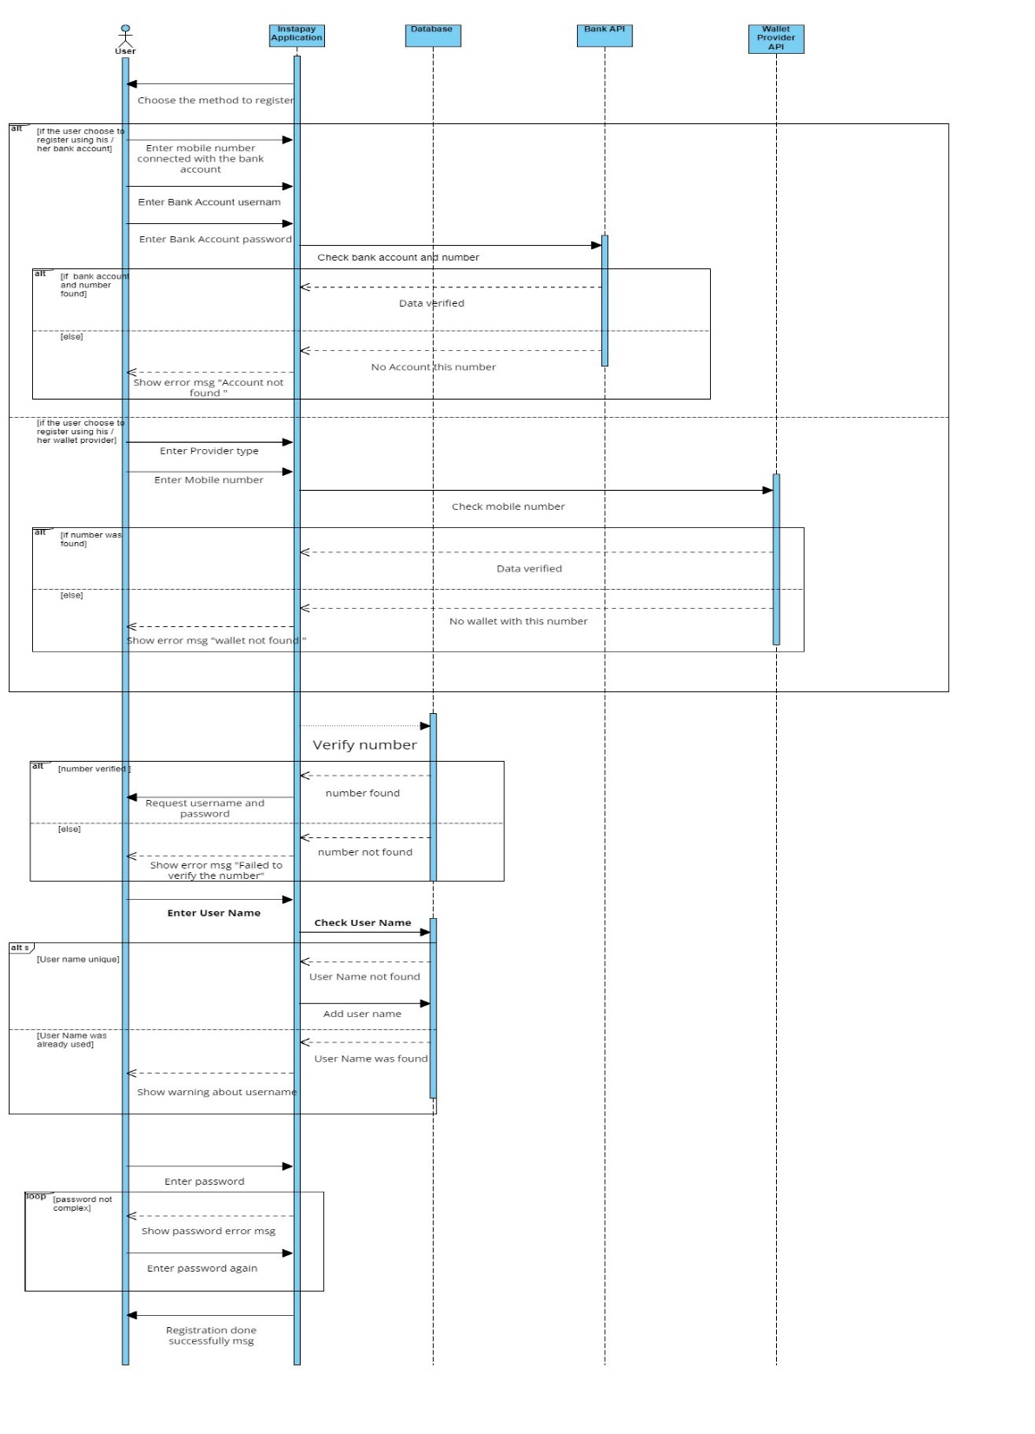

**2 – Sign In**

**3 – Transfer to Wallet and Instapay account only**

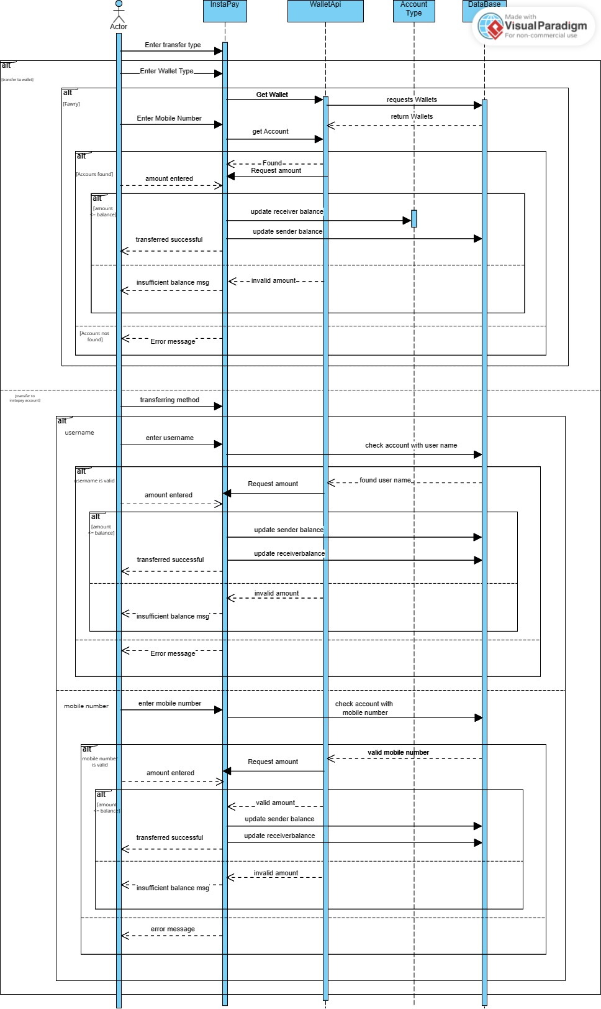

**4 – Pay Bills**

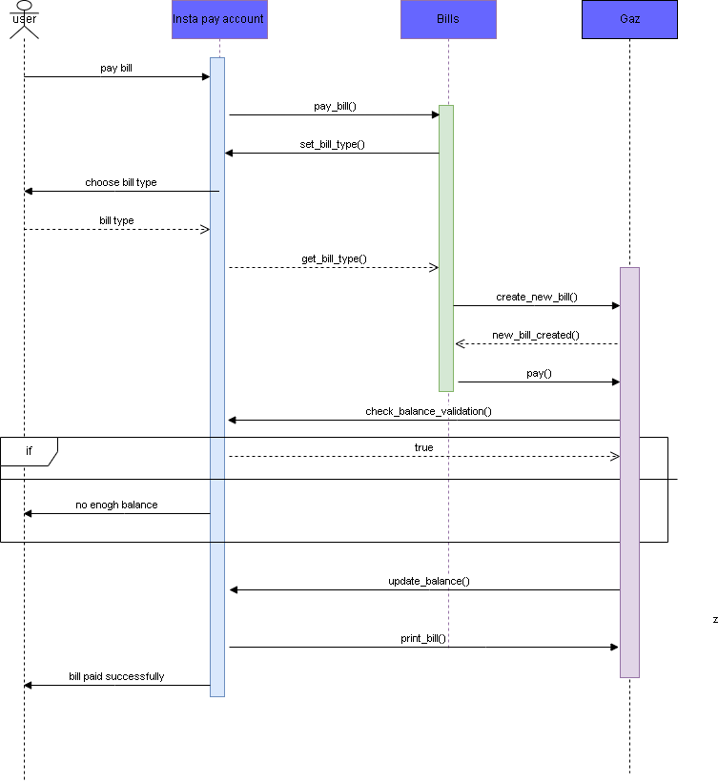

# 

# Github repository link

* <https://github.com/3ab2wy1911/Instapay_system>